Jade Pearl
COSC 320-001 Lab 04: Tree Traversal 2/28/2023

Lab report: I have finished all the tasks of the lab on my own and took about 3 hours to complete.

Pre-lab:
- Review the information about binary tree traversal and understand different orders of nodes: in-order, pre-order, post-order, level-order
- Read and understand the d_tnode.h and d_tnode1.h files and the functions inorderOutput, postorderOutput, levelorderOutput

Files Created:
lab_04.cpp

Lab 4
Exercise 1: Build expression trees out of infix expressions (no code for this part of the lab. Lab Question)
  - a*b:

  - a+b*c:

  - a+b*c/d-e:

Exercise 2-4: Pre-order and post-order of the above trees (Lab Question)
1.1:
Pre-Order (NLR): * a b
Post-Order (LRN): a b *
1.2:
Pre-Order: + a * b c
Post-Order: a b c * +
1.3:
Pre-Order: - + a / * b c d e
Post-Order: a b c * d / + e –

Pre-Order: indicates the prefix form because it observes the root, then left child, and then right child
Post-Order: indicates the postfix form because it observes the left child, right child, then the root last

Exercise 5: Design and implement void prefixoutput(tnode<char> *exp)
Design: as observed, the prefix form of a binary expression tree can be found with the pre-order
Implementation:
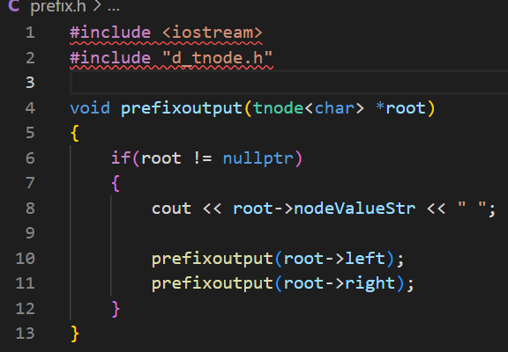

Exercise 6: input the infix expression to output an expression tree. Output the prefix form of the expression, output postfix by traversing the tree using postorderOutput(), display the tree with displayTree()

Source Code:
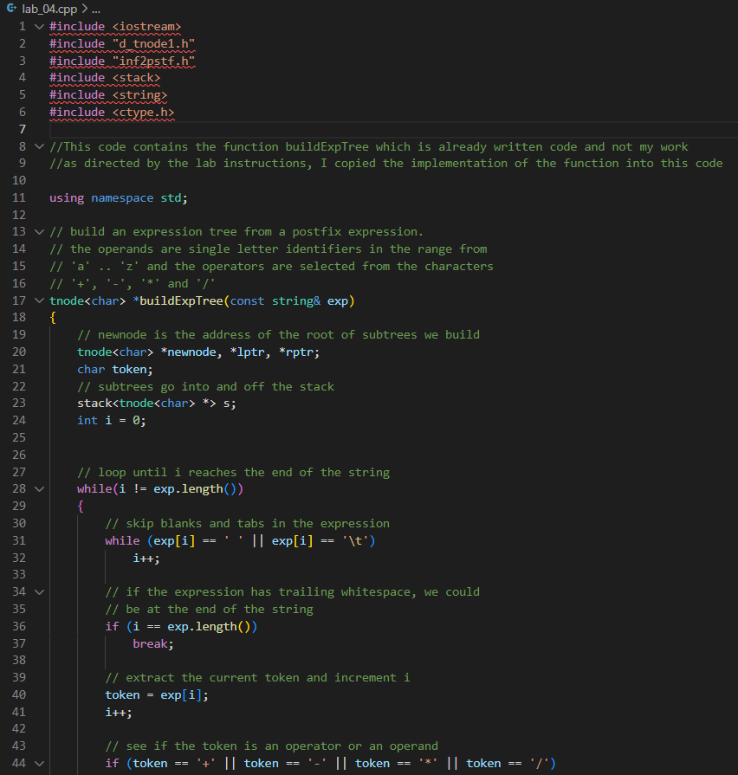
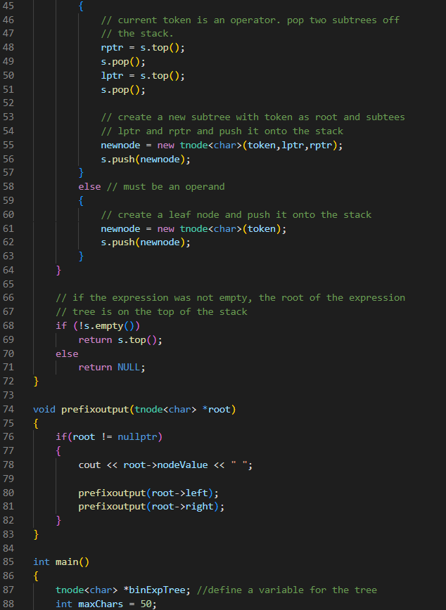
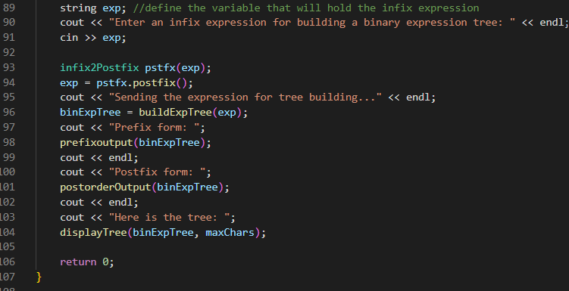

Sample Outputs:
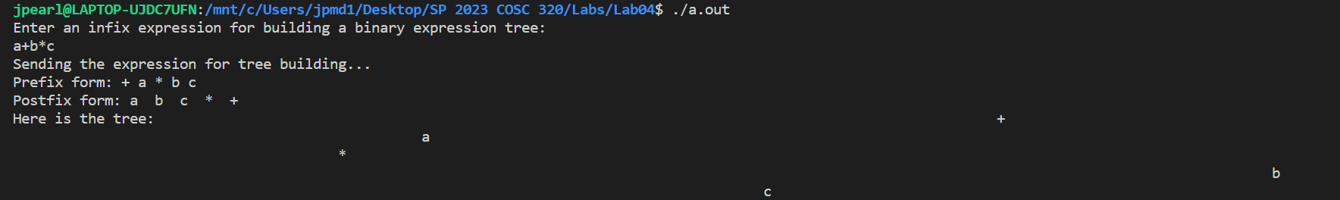
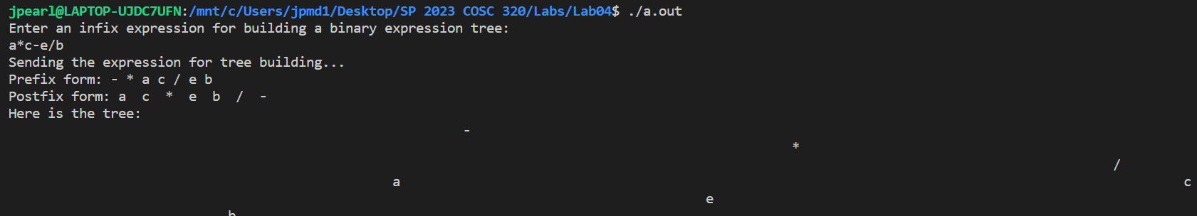
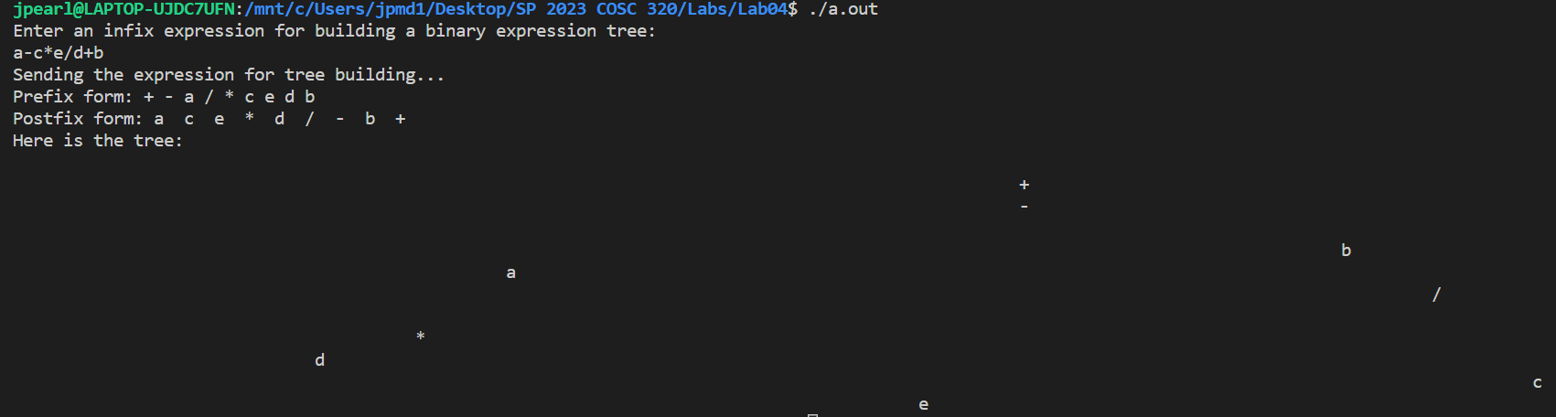

There is only one tree used for this lab, so the sample output is the same each run.

Questions for the lab were completed earlier in this report!

